**Evaluation and Results**

As told in our analysis our context we have concentrated on the effects an ineffective parking systems on environment. To ensure we have given equal importance to various components in the pollution data set. To identify the important and significant parameters we performed the step wise regression techniques to get the information of the significant variables that impact the analysis. We used the most significance variables to perform our analysis. Our analysis was concentrated mostly one four key parameters. They are 1. Vehicle count 2. Ozone content 3. Total spaces and 4. Garage code. To identify the key parameters we ran the step wise regression. Based on the results of the step wise regression we chose the ozone as the dependent variable and the remaining parameters that is vehicle count, total space and garage code as the independent variables. Post identifying the key parameters we performed the multiple linear regression on the key parameters. The analysis done in this regard will be helpful in building a better infrastructure for the parking in the city and also help in taking measures in the ensure we create better planned infrastructure to ensure that the search for parking is not a tedious process. We will discuss in detail in the following steps what are the parameters we looked upon.

The first step before implementing the multiple linear regression we performed the residual analysis to identity we can run the linear regression on the data set. The reason we performed the residuals analysis to identify if we can run the linear regression on the account to perform the analysis. On the basis of the analysis we had with the standard residual and the fitted values. Based on the analysis we identified that there are number of the data points in the data set were randomly dispersed around the horizontal axis and that was the number of random distributions of the data points along the horizontal axis. This gave us the freedom to use the linear machine learning algorithm. Hence this gave the founding base for our analysis.

**Residual Graph**

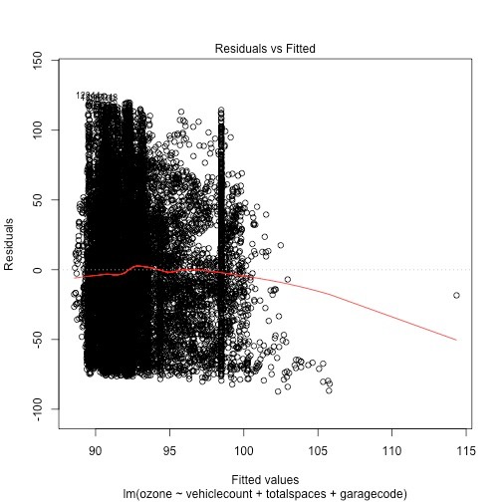

The next analysis we performed a standardized residuals analysis to understand the distribution of the data points and identify the outliers in the data set. Firstly we had to identify residuals which is the difference between the observed value and the predicted value. Each residual has a different variance. These residuals gave us three major characteristics. They are:

1. The residual is bound randomly around the zero line. This suggested that assumptions that relationship is linear is reasonable to make.
2. This also suggests that the variance of the error terms are equal.
3. There was only one residual “stand out” from basic random pattern of residuals. This suggests that there is a very low outliers.

We got a clear cut analysis of the parameters which gave us an idea about the parameters which impact the ozone parameters. The figure given us that the analysis of the standardized residuals and the fittest values.

**Standard Residual Vs Fitted Model**

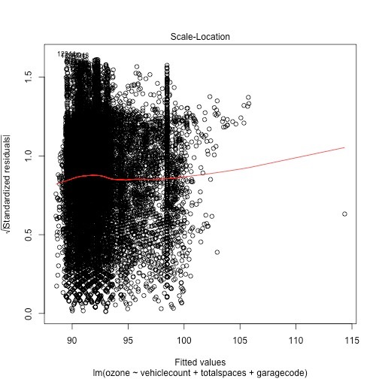

**QQ Plot**

The next analysis we performed is to identify if there was any correlated to each other. To identify this we performed the Q-Q Plot to identify this. QQ plot is a probability plot which is a graphical method for comparing two parameters if they are correlated. The points plotted in a QQ plot are always non-decreasing when viewed from left to right. If the two distributions being compared are identical the QQ plot follows a forty five degrees line which is equivalent to the equation y=x. In our analysis we found that there are no correlated which made our analysis easy. We plotted the data points of the dependent variables and the independent variables to understand the correlated.

**The figure gives us the QQ plot analysis of the data points.**

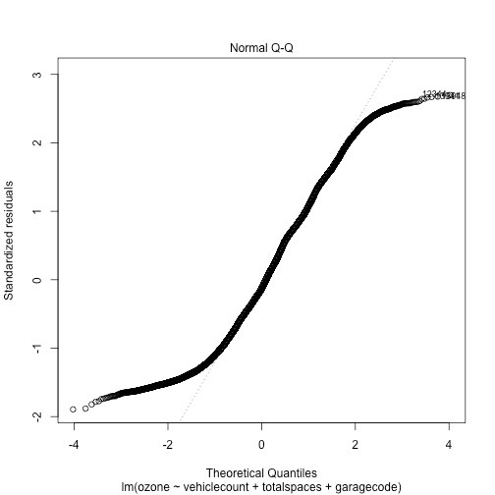

Once we got the basic parameter analysis and the assumptions are made we tried to build a time series model to perform the further analysis and predict the impact of various parameters on the ozone parameters.

Post running the basic regression analysis we ran the time series to understand the impact of the various parameters on the ozone layers. The time series gave the number predictions which we could make a number of predictions. We first tried to understand the moving and running average of the ozone layer. As we see the figure below it was shows that the analysis of the moving average and the average of the ozone index.

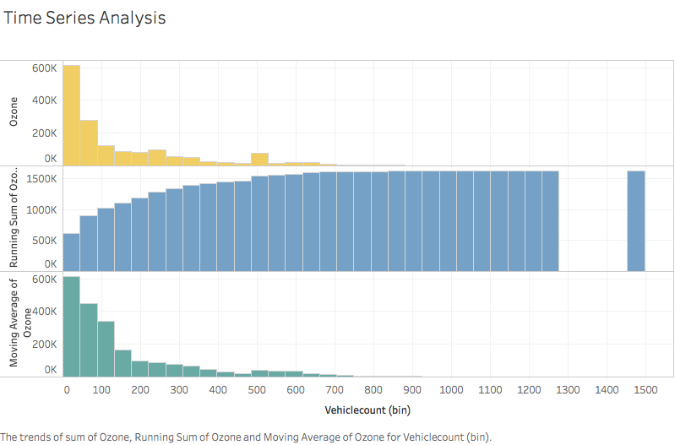

The next analysis was the impact of the number of vehicles or vehicle count and its impact on the ozone layer. We noticed that as the number of vehicles in the area increases we find that there are a decrease in the ozone layer. This is an alarming situation. The decrease in ozone layers will lead to a number of natural calamities. This analysis will gave us an idea about the reason for the ozone layer effect.

The below figure gives us an idea about how the vehicle count impacts the ozone layer.

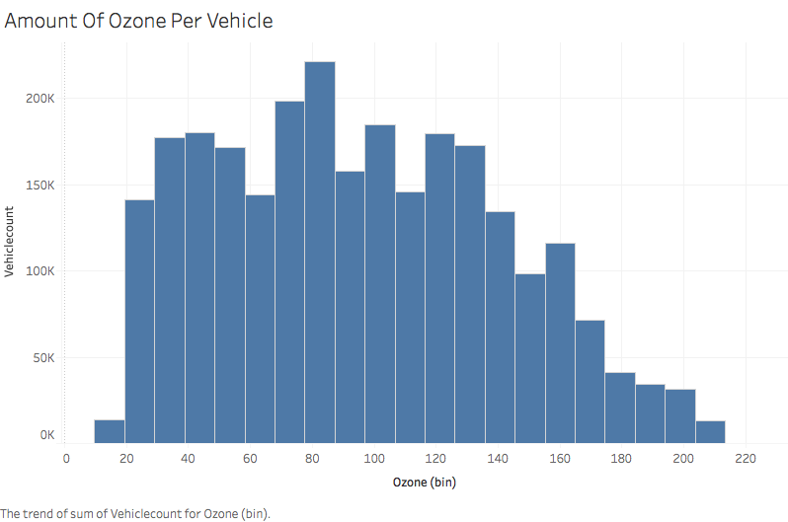

The key parameters which impact our dependent variable was vehicle count. Hence we performed another analysis on the same parameters. We have done another analysis with the same parameters. The below figure gives us the detailed information of how the vehicle count near the garage code which was given in the data set. This will be giving us the idea where there are more vehicles in thea region and better parking arrangements needs to be made.

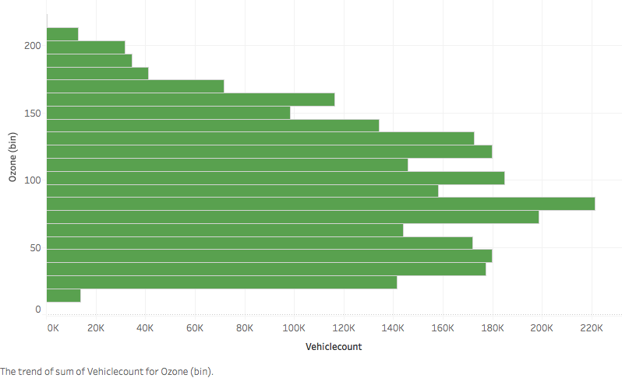

Our attempt for performing the entire analysis is to identify which of the parameters in parking are impacting the ozone layer the most. We chose the ozone content as this is the most important component of the atmosphere which will affect the environment. Hence based on the analysis on performing the linear analysis and time series analysis. We have tried to use the basic machine learning algorithms to get the initial analysis of the area where there are parking issues and the city administration can make a few arrangements accordingly.